# **Product Description**

Create Personalized skincare recommendations powered by AI and Machine Learning based on consumer unique skin needs, and to equip beauty brands with a new way to enhance their customer experiences and drive sales and recommend tailored skincare solutions.

# **Product Scope**

* Smart Camera Mode - Capture Image and provides feedback on factors like face positioning, angle, size, and lighting, optimizing the input for the AI. This ensures that the AI system receives the best possible images for analysis.
* Analyze skin types and conditions.- identify patterns associated with different skin conditions. For example, the AI will learn what wrinkles look like across many different images and then be able to spot wrinkles in new, unlabeled images.
* Analyze facial features such as wrinkles, pores, or signs of acne.
* Create Skin scores and product recommendations to individuals

Leverage **augmented reality (AR)** powered by **machine learning algorithms** to offer virtual try-on experiences.

Machine learning (ML) uses computational models to perform intelligent predictions based on training datasets without direct human intervention.

# **Product Requirements Specification**

## **Data Interface Requirements**

Product shall receive Skin images adhering to Clinical images quality from Mobile App

## **Data Processing Requirements**

Deep Learning Layer process Clinical images and store them for Analytics Layer

# **Data Log Requirements**

Log all data for Skin condition status and events

## **Data Analysis Requirements**

Classification Layer will classify skin conditions

Analytics Layer shall analyse to skin severity

Outcome Layer shall use Classification & Analytics Layer to produce Skin condition outcome.

Treatment Layer recommend Dermatologist/Treatment based on above 3 layers

# **Platform requirements**

Product shall be deployed on a Apple Store and Google Play store to be used for End Users

System shall have the ability to process and store data on a cloud-computing platform

# **Software Design Specification**

## Product Design

1. Image Preparation: Just like a dermatologist might adjust lighting or ask to remove makeup before an examination, AI tools first prepare the selfie for analysis. This can involve adjusting for lighting variations or cropping the image to focus solely on the face.

2. Feature Extraction: With the image prepped, the algorithms get to work, acting like a dermatologist's magnifying glass. They examine the image, extracting key features that reveal insights about skin. These include:

Geometric Features: Platforms typically measure facial proportions, distances between key points (like eyes, nose, and mouth), and angles to assess facial structure and symmetry.

Textural Features: Algorithms analyze the patterns in skin texture to identify wrinkles, pores, and roughness.

Colorimetric Features: By analyzing the distribution of colors and their intensities, AI can assess skin tone, pigmentation, and the presence of redness or discoloration.

3. Machine Learning Models: The extracted features are then fed into machine learning models, which act as the AI's vast knowledge base. These models have been trained on extensive datasets of skin images and can typically identify skin type (oily, dry, etc.) and conditions like rosacea, predict skin age or wrinkle severity, and highlight specific areas like acne, pores, or dark spots.

4. Result Generation: Based on the analysis, the models generate a skin report – akin to a dermatologist's treatment plan. This report typically includes scores for different skin parameters, along with explanations and recommendations.

Data Flow

ER Diagram

**Technologies**

**Model Creation:**

**Model Loading :**

**UI Workflow:**

1. Consumers upload image and our app check if valid skin image

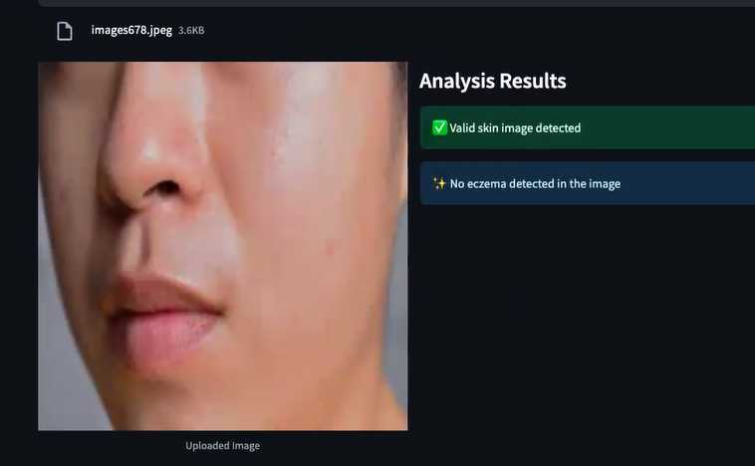

2. Based on Skin detection, recommend the products

3. Consumers can now virtually try on over 400 shades of products across complexion, cheek, eye and lip categories on the brand’s website.

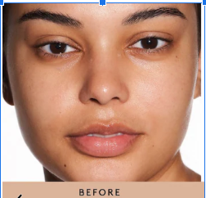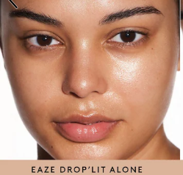

4. Consumers can the split the screen icon to see one shade on vs. one shade off, and even download the picture to show and share selections

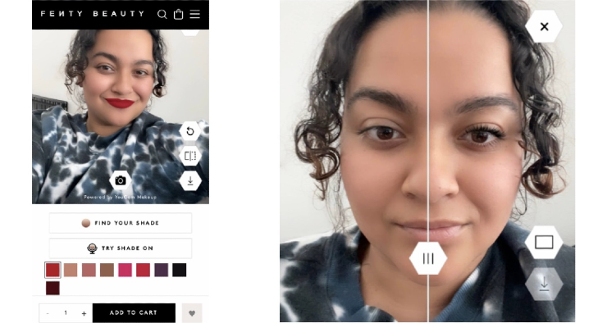

.

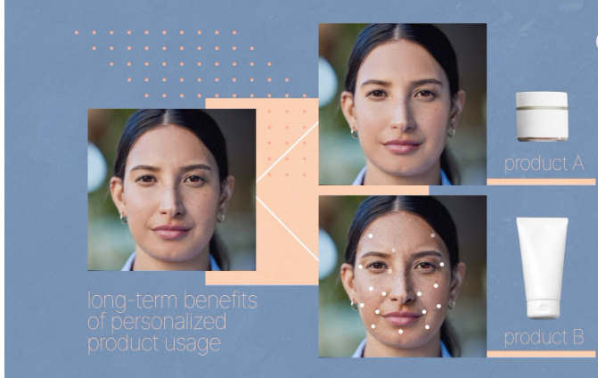

5. Consumers will have option for Virtual Consultation with Certified Beauty Experts

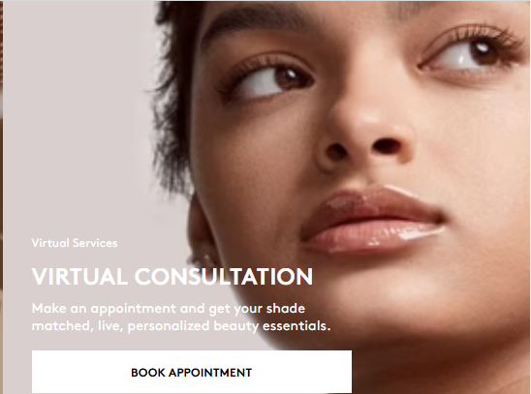

## Next Steps:

[POC 1 - Google Docs](https://docs.google.com/document/d/1KVRrHhgyhweSpvEuYCTEvMnR6pLoL9TONINqaS_Yw2I/edit?tab=t.0#heading=h.mab5srpxojye)

[POC2 - Google Docs](https://docs.google.com/document/d/1W1DVZ3ZAB_ZtUjwqSG8mJ-Q1ovOAqYJtCNZv6PiE6Pg/edit?tab=t.0)

## 

## References

[US11832958B2 | Automatic Image-Based Skin Diagnostics Using Deep Learning | Loreal](https://slate.greyb.com/patent/US11832958B2)

[Deep learning-aided decision support for diagnosis of skin disease across skin tones | Nature Medicine](https://www.nature.com/articles/s41591-023-02728-3)